Quiz
15 Questions to Decide if Your Relationship Has a Future

 Yes |  No | - Does your partner make you a better person, and do you do the same for them?
 Yes |  No | - Are you and your partner both comfortable with sharing feelings, relying on each other, being close, and able to avoid worrying about the other person leaving?
 Yes |  No | - Do you and your partner accept each other for who you are, without trying to change each other?
 Yes |  No | - When disagreements arise, do you and your partner communicate respectfully and without contempt or negativity?
 Yes |  No | - Do you and your partner share decision-making, power and influence in the relationship?
 Yes |  No | - Is your partner your best friend, and are you theirs?
 Yes |  No | - Do you and your partner think more in terms of “we” and “us,” rather than “you” and “I”?
 Yes |  No | - Would you and your partner trust each other with the passwords to social media and bank accounts?
 Yes |  No | - Do you and your partner have good opinions of each other – without having an overinflated positive view?
 Yes |  No | - Do your close friends, as well as your partner’s, think you have a relationship that will stand the test of time?
 Yes |  No | - Is your relationship free of red flags like cheating, jealousy, and controlling behavior?
 Yes |  No | - Do you and your partner share the same values when it comes to politics, religion, the importance of marriage, the desire to have kids (or not) and how to parent?
 Yes |  No | - Are you and your partner willing to sacrifice your own needs, desires, and goals for each other (without being a doormat)?
 Yes |  No | - Do you and your partner both have agreeable and emotionally stable personalities?
 Yes |  No | - Are you and your partner sexually compatible?

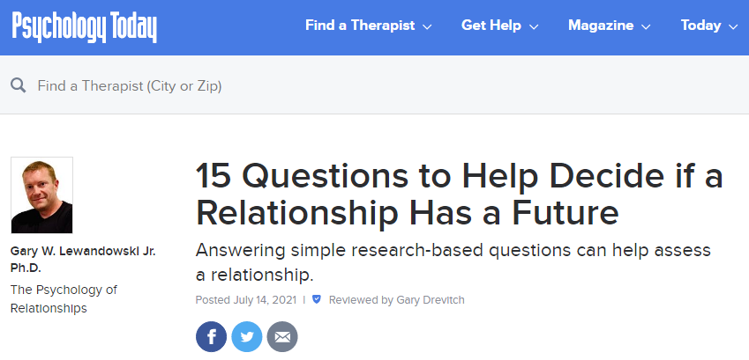
Link

www.PsychologyofRelationships.com

